ReelSome Pro

Software Requirements Specification

Version 2

05 March 2026

Group 15

Aden Moon, Amani Paul, & Jaylan Luong

Prepared for
CS 250 - Introduction to Software Systems
Instructor: Gus Hanna, Ph.D.
Spring 2026
Revision History

Date Description Author Comments
19 Feb 2026 | Wrote 1.2-1.3, 2.2-2.5, 3.3a, 3.3.3, 3.4a | Aden Moon | Also worked on formatting of the SRS document.
19 Feb 2026 | Worked on External Interface Requirements and found possible APIs online that our Ticketing System can use. | Jaylan Luong | Currently unsure if all the APIs will be used for the Ticketing System but included anyway. Will narrow decisions as a group later.
26 Feb 2026 | Implemented Use Cases | Amani Paul | Forgot to include diagrams showcasing use case scenarios
05 Mar 2026 | Completed UML diagram and UML description | Aden Moon | Made corrections to points marked down from version 1 and worked on UML diagrams and the descriptions.
5 Mar 2026 | Completed SWA Diagram and SWA Description | Jaylan Luong | Pretty sure that the SWA diagram holds all major functions of our ticketing system. Included APIs as External resources as a part of the diagram in a similar format to the SWA template on the modules in Canvas.
5 Mar 2026 | Completed task responsibilities and timeline; added GitHub repo; updated section titles for new additions | Amani Paul | Unsure of how team responsibilities need to be specified; decided to include general sections with most importance

Document Approval

The following Software Requirements Specification has been accepted and approved by the following:

Signature Printed Name Title Date
Aden Moon | Aden Moon | Designer | 05 Mar 2026
Jaylan luong | Jaylan Luong | Designer | 05 Mar 2026
Amani Paul | Amani Paul | Designer | 05 Mar 2026

Table of Contents

REVISION HISTORY ...................................................................................................................................................2
DOCUMENT APPROVAL ...........................................................................................................................................3
1. INTRODUCTION ......................................................................................................................................................5
1.1 PURPOSE ................................................................................................................................................................5
1.2 SCOPE .....................................................................................................................................................................5
1.3 DEFINITIONS, ACRONYMS, AND ABBREVIATIONS .....................................................................................5
1.4 REFERENCES .........................................................................................................................................................5
1.5 OVERVIEW .............................................................................................................................................................6
2. GENERAL DESCRIPTION ......................................................................................................................................6
2.1 PRODUCT PERSPECTIVE ....................................................................................................................................6
2.2 PRODUCT FUNCTIONS ........................................................................................................................................6
2.3 USER CHARACTERISTICS...................................................................................................................................6
2.4 GENERAL CONSTRAINTS ...................................................................................................................................6
2.5 ASSUMPTIONS AND DEPENDENCIES ..............................................................................................................7
3. SPECIFIC REQUIREMENTS ...................................................................................................................................7
3.1 EXTERNAL INTERFACE REQUIREMENTS.......................................................................................................7
3.1.1 User Interfaces ......................................................................................................................................................7
3.1.2 Hardware Interfaces ..............................................................................................................................................7
3.1.3 Software Interfaces.................................................................................................................................................7
3.1.4 Communications Interfaces....................................................................................................................................8
3.2 FUNCTIONAL REQUIREMENTS ........................................................................................................................8
3.2.1 Ticket Checkout ....................................................................................................................................................8
3.3 USE CASES ............................................................................................................................................................8
3.3.1 Use Case #1...........................................................................................................................................................9
3.3.2 Use Case #2.........................................................................................................................................................10
3.3.3 Use Case #3..........................................................................................................................................................10
3.4 CLASSES / OBJECTS ...........................................................................................................................................11
3.4.1 Class Descriptions................................................................................................................................................11
3.5 NON-FUNCTIONAL REQUIREMENTS ............................................................................................................12
3.5.1 Performance ........................................................................................................................................................12
3.5.2 Reliability ............................................................................................................................................................12
3.5.3 Availability ..........................................................................................................................................................12
3.5.4 Security.................................................................................................................................................................13
3.5.5 Maintainability ....................................................................................................................................................13
3.5.6 Portability.............................................................................................................................................................13
4. SOFTWARE DESIGN SPECIFICATION................................................................................................................14
5. DEVELOPMENT PLAN & TIMELINE..................................................................................................................16
1.1 Purpose:
The purpose of this SRS is to provide all the features and requirements for a movie ticketing system software that will be used by movie theaters across the country to sell their tickets digitally. The intended audience of this SRS is for software engineers that will be designing our software based on our specifications and for movie theater companies that will use our system to sell their tickets.

1.2 Scope:
ReelSome Pro is a mobile and web browser-friendly software that allows customers to find movies, purchase tickets, select seats, and order food/beverages which they will receive via email with a QR code. It provides movie theater staff functions for managing movies, showtimes, pricing, seating, and food through the software.

1.3 Definitions, Acronyms, Abbreviations:
- QR code: Digital ticket that is scannable on a mobile device.
- SRS: Software Requirements Specification.
- API: Application Programming Interface.
- SMTP: Simple Mail Transfer Protocol.
- SWA: Software Architecture.

1.4 References:
- Cloudflare. (2025). What is https? Cloudflare. https://www.cloudflare.com/learning/ssl/what-is-https/
- Institute Of Electrical And Electronics Engineers. (1998). IEEE recommended practice for software requirements specifications. Ieee.
- Krüger, N. (2023, January 17). How to write a software requirements specification (SRS document) | perforce software. Perforce Software. https://www.perforce.com/blog/alm/how-write-software-requirements-specification-srs-document.

1.5 Overview:
The SRS will contain product context, its uses, and constraints. The detailed requirements will be given for functionality, interfaces, use cases, classes/objects, and non-functional requirements.
2. General Description

2.1 Product Perspective:
An online movie ticketing system provides and stores the following information:
- Movie Details:
  - Includes the movie names, images, dates, movie length, and show times, as well as the theater they are located in and seating availability.
- Customer Information:
  - If the customer has an account, their login and payment information are saved. Along with their past purchases and current number of reward points saved.
  - If the customer doesn’t have an account, their email is saved during guest checkout, where their ticket ID is saved as a barcode/QR code.
- Ticket Information:
  - Includes the customer’s name, movie name, time, theater, and seat.

2.2 Product Functions:
- Customer: Search movies and showtimes, view seating options, view pricing, purchase tickets, food, and beverages, access ticketing QR code, view order history, create an account, and request a refund.
- Staff: Create movies and showtimes, configure seating arrangements, configure pricing, update promotions/discounts, view sales, and view movie attendance.

2.3 User Characteristics
Users of the movie ticketing system should be able to view movies across different dates and times on a smartphone or website.

2.4 General Constraints
ReelSome Pro must work on modern browsers (Chrome/Safari/Firefox, etc.) without issue as well as on apps. The software will work properly on mobile devices without crashing. It must work with a third party company for secure transactions at checkout. Software will have security for users who create accounts and save credit card information.

2.5 Assumptions & Dependencies
Assume customers have a mobile device with internet access. Customers have a valid e-mail address to receive ticketing information. Customers have a charged device to show QR code in person at the theater. Third party payment company works properly for customer checkout. The movie theater must provide accurate movie showtimes and seating arrangements as well as updating seats/tickets already purchased. Movie theaters have access to QR code scanning equipment. Movie theaters will identify if the customer fits the description for their discounted tickets (adult, child, or senior) at the movie theater.

3. Specific Requirements
3.1 External Interface Requirements

3.1.1 User Interfaces
- Home page
- Current/popular movies right now
- Movie details (length, actors, director, etc)
- Showtime selection by date and time
- Seat selection with open and taken indicators
- Cart to checkout
- Login for users with an account
- Order history in account
- Discounts/promotions
- Third party secure checkout
- Refund request
- Order confirmation
- QR code ticket
- Error handling for taken seats

3.1.2 Hardware Interfaces
- QR code scanner for tickets

3.1.3 Software Interfaces
- Paypal (Tracking payments)
  - Allows users to pay for tickets on the website.
- Sendgrid (Email API)
  - Send confirmation emails for purchased tickets.
- Google Maps API
  - Find nearby theaters with available tickets.
  - Sends users to Google Maps for directions to the theater.

3.1.4 Communication Interfaces
- HTTPS
  - Sends data between web browser and website.
  - Data transfer is encrypted for user’s privacy.
- Rest APIs
  - Used to communicate between frontend and backend.
  - Users can login to their email, pay for tickets, etc.
- Simple Mail Transfer Protocol (SMTP)
  - Allows us to send emails to the customer.

3.2 Functional Requirements

3.2.1 Ticket Checkout

3.2.1.1 Introduction
This function holds the seats that the user selects for 2 minutes in their cart. If they do not purchase tickets within the 2-minute timer, these tickets will be available for users to buy in real time.

3.2.1.2 Inputs
The user selects on-screen seats labeled by their row and column numbers.

3.2.1.3 Processing
The website holds these seats for two minutes for the user and indicates to other users in real time that those ticket checkout holder seats are unavailable. If the tickets aren’t bought within the two-minute timer, the tickets will be available for others, and the user will need to refresh the page to be able to put the tickets in their cart.

3.2.1.4 Outputs
If the user purchases tickets, our website will indicate to users that those seats are unavailable. The purchaser receives a confirmation email of the ticket with the seat number, movie name, and movie date.

3.2.1.5 Error Handling
- If a user’s card gets declined when purchasing the tickets (insufficient funds), the user will be prompted with a message that their card was declined. Then the seats will be marked as available again.
- If a user tries to pick the same seat as another user had picked, the user will be prompted with a message that the seat was already taken.
- If the user does pay for their ticket within two minutes after adding their tickets in the cart, the cart will be cleared and the seats will be available again.
- If someone enters the wrong login information for their email, an error message will be prompted that their login information was wrong. If the user gets their login information wrong 5 times, the login will be timed out for 30 minutes to avoid mass logins.

3.3 Use Cases

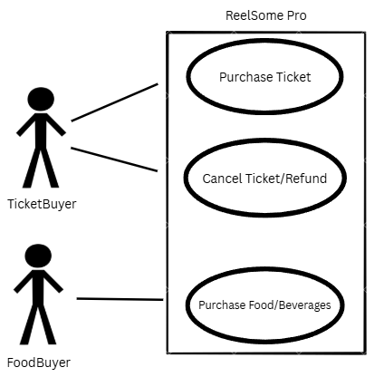Figure 3.3: Use Cases

3.3.1 Use Case #1
Name: Purchase Ticket
Actor(s): TicketBuyer
Flow of events:
- TicketBuyer connects to ReelSome Pro Server.
- Server checks if TicketBuyer is logged in to an account already.
- TicketBuyer selects a movie and date from a list of available screenings.
- TicketBuyer chooses an available time and screening type from the chosen movie.
- TicketBuyer then chooses a limited number of seats to be added to their cart, within a given time frame.
- If TicketBuyer has an account and is logged in, they checkout with their saved payment method. Otherwise, they check out as a guest and add their email address and a payment method.
- A confirmation email is sent to TicketBuyer, consisting of a QR Code for each purchased ticket.
- If a Ticket Buyer has an account, their QR Code is also saved directly within their account.
3.3.2 Use Case #2
Name: Purchase Food/Beverages
Actor(s): FoodBuyer
Flow of events:
- FoodBuyer connects to ReelSome Pro Server.
- Server checks if FoodBuyer is logged in to an account already.
- FoodBuyer selects a theater from a list of nearby locations.
- FoodBuyer views a list of available food and beverage items, picking specified modifications and adding chosen items to their cart.
- If FoodBuyer has an account and is logged in, they checkout with their saved payment method. Otherwise, they check out as a guest and add their email address and a payment method.
- A confirmation email is sent confirming the purchased items.

3.3.3 Use Case #3
Name: Cancel Ticket/Request Refund
Actor(s): TicketBuyer
Flow of events:
- TicketBuyer connects to ReelSome Pro server.
- TicketBuyer selects previously purchased ticket from purchase history.
- Server displays the ticket details (movie, date, time, seat number) and shows if cancellation is allowed.
- Server checks to make sure the ticket hasn’t already been used.
- If ticket has not been used and is in allowable window for refund, the server processes the refund back to the original payment method.
- Server will update the seat to be marked open.
- A confirmation email is sent to the TicketBuyer showing proof of cancellation and refund.

3.4 Classes / Objects

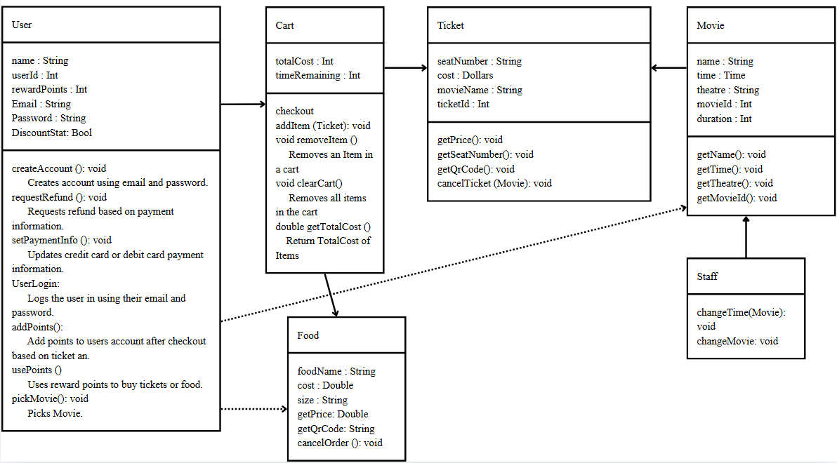
Figure 3.4: Classes / Objects

3.4.1 Class Descriptions:
The ReelSome Pro software consists of a few core classes that represent the users, purchases, and theater information. The following classes define the primary objects used in the system’s framework.

User: Represents a customer using ReelSome Pro software to create an account, store account information, use reward points, request refunds, and pick movies.
- This class contains attributes such as name, userId, rewardPoints, Email, Password, and DiscountStat to store customer information.
- User class uses operations createAccount, requestRefund, setPaymentInfo, UserLogin, addPoints, usePoints, and pickMovie to allow the user to interact with the software.
Cart: Temporarily stores selected movie tickets, seats, and food items before checkout.
- The Cart class maintains attributes totalCost and timeRemaining to keep track of the cart value and seat time holder.
- Operations for this class include checkout, addItem, removeItem, clearCart, and getTotalCost to manage items in the cart.

Food: Shows food/beverage/candy items available for purchase and their costs.
- The attributes for the food class include foodName, cost, and size which store information for each item purchased.
- The Food class uses operations getPrice, getQrCode, and cancelOrder to get pricing information, generate the QR code for pick up, and cancel food orders if need be.

Ticket: Represents a purchased ticket containing the movie details, price, seat number, and unique ticket ID with QR code.

- The attributes used for the Ticket class include seatNumber, cost, movieName, and ticketId which are used to identify each ticket and store the details.
- The operations used are getPrice, getSeatNumber, getQrCode, and cancelTicket allow the software to get ticket information, generate a QR code, and cancel the ticket if needed.

Movie: Stores the movie information such as title, showtime, theatre number, and duration.
- This class utilizes attributes name, time, theatre, movieId, and duration for describing the movie details for its scheduled showing.
- The Movie class includes operations getName, getTime, getTheatre, and getMovieId which allow the software to retrieve information about the movie and its screening.

Staff: Represents the movie theatre staff responsible for managing movies, showtimes, seat information, and updating system data.

- The Staff class contains operations changeTime and changeMovie which update showtimes and modify movie information.

3.5 Non-Functional Requirements

3.5.1 Performance
The server will run and be readily available through web and app interfaces with high connection speeds and minuscule delays between function access and page changes. There will also be server expansions in case of events that induce high traffic on the server, to prevent reduced speeds and access to important features.

3.5.2 Reliability
ReelSome Pro Server should be consistent with the ability to perform its functions and services. In case of loss in network connectivity or the end of the connection with the server by user, then the server should save the last instance of the cart.

3.5.3 Availability
With a stable internet connection and update application, the server should be readily available at all times, unless in the case of a planned, timed maintenance (of which should be conducted during the least busy user traffic).

3.5.4 Security
The server will be protected from malicious attacks with the appropriate protective design philosophies and implementation of antivirus software. User info will be held in a protected database and efficiently encoded. To protect against bot activity, users will be required to solve a captcha.

3.5.5 Maintainability
Routine checks will be performed to make sure the server is properly running and the application is performing its intended functions effectively. As previously stated, these will take place during the times of least user traffic to ensure the software is available at the most important times.

3.5.6 Portability
The software would be able to be used on portable devices such as smartphones and laptops, with easy access to the user’s account and information through simple log-in.

4. Software Design Specification
SWA: 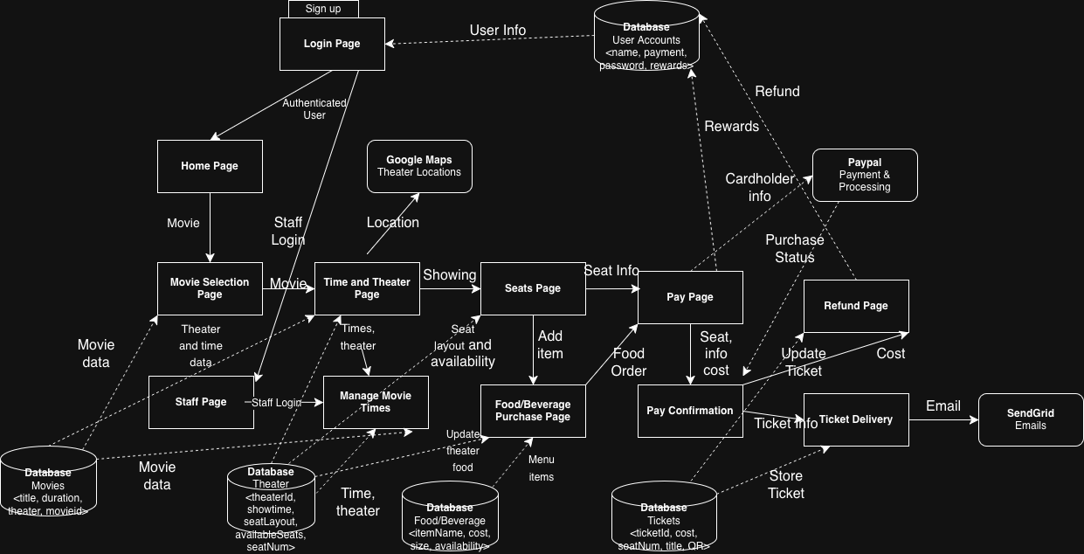
Figure 4.1 SWA

SWA Description:
- Login Page: This page communicates with a User Accounts Database that is used to authenticate the user for their login. Consumers will then be sent to the Home Page while Staff members are sent to the Staff Page.
- Home Page: The main page of the Reel Some Pro that navigates towards the movie selection page.
- Movie Selection Page: This page shows current available movies through retrieving movie data from the Movie Database. Movie data consists of the title, duration, theater, and movieId. Users can select a movie and will be prompted to the Time and Theater Page.
- Time and Theater Page: This page shows users the time and theaters that are airing that movie using the movie id from the movie database and the showtime and theaterId from the Theater Database. A Google Maps API is used for users to be able to locate theaters nearby that ReelSome Pro sells tickets for. After the user makes a selection, they are prompted to the Seats Page for the theater page.
- Seats Page: Users in this page can select their seats based on the seat layout and the available seats based on the theater Id that they chose from the Theater Database. Users will be able to choose a type of seat based on age range that will be sent to the Pay Page. Users can then either add food/beverages and be sent to the Food/Beverage Purchase Page, or they can be sent other Pay Page.
- Food/Beverage Purchase Page: Users can add items to their total purchase that is communicated with the items they choose that is communicated with the Food/Beverage Database. The data sent are the itemName, cost, and availability of the food. This page also uses the theaterId from the theater database to display the correct foods based on the specific theater. After selections, user will be sent to the Pay Page.
- Pay Page: Collects all the information acquired based on the number of seats chosen and seat type from the Seats Page and the items selected from the Food/Beverage Purchase Page. This page uses the User Accounts Database to retrieve the necessary payment information and rewards that can be used for their total cost. A Paypal API is used to handle the user’s payments using the information retrieved from the User Accounts Database. The Users will then be sent to the Pay Confirmation Page
- Pay Confirmation Page: Users will be able to see their order confirmation and the total cost of their tickets and items. This information will be sent to the Ticket Delivery. Users will also be able to refund their tickets by
- Ticket Delivery: Generates a QR code with the seat number and title of the film that is stored in the ticket in the TicketDatabse. A confirmation email is sent to the user through the SendGridAPI.
- Refund Page: Users are able to refund their ticket using the payment information from the User Accounts Database. The ticket is then updated in the Tickets database to make the seat available again.
- Staff Page: Landing page for staff after login and is sent to manage movie times page
- Manage Movie Times: Allows staff to update movie, theater, and food/beverages information on their pages from their respective databases.
- External services: Paypal handles and processes all payments. Google Maps is used to provide theater locations and directions for users to the theaters. SendGrid handles emailing to users their tickets.

5. Development Plan & Timeline

- Team member responsibilities
  - Jaylan Luong - SWA Diagram and Description, External Interface Requirements, Overview
  - Aden Moon - UML Diagram and Class Description, General Description, Functional Requirements
  - Amani Paul - Use Cases, Non-Functional Requirements, Table of Contents, Tasks, GitHub Repository

- Timeline
  - 2/19: External Interface Requirements, Overview, General Description, Functional Requirements, Table of Contents
  - 2/26: Use Cases, Non-Functional Requirements
  - 3/5 : UML Diagram and Class Description, GitHub Repository, Tasks

